Subtraction as an Art Form: Brian Pinkney and Floyd Cooper
Femelyne C. Wesolowski
San Jose State University
October 31, 2012

Author Note
Femelyne C. Wesolowski, LIBR 263-10, School of Library and Information Science, San Jose State University.
Correspondence concerning this paper should be addressed to Femelyne C. Wesolowski, Post Office Box 25677, Barrigada, Guam 96921. Contact: femywesolowski@gmail.com

Subtraction as an Art Form: Brian Pinkney and Floyd Cooper
An art technique shared by Brian Pinkney and Floyd Cooper is the “subtraction” technique. Each illustrator takes away parts of the medium used as foundation when creating their illustrations. Brian Pinkney uses the “scratchboard technique.” He covers a white board with black ink then “scratches” away the ink to expose the white background as he details his pictures. He then uses Luma watercolor to preserve the white background he needs and later uses acrylic paint to add color. (Art Materials, 2001-2010; Pinkney, 2012, Bibliography; Pinkney, 2012, FAQs)
Floyd Cooper, on the other hand, covers a board with oil wash then, literally, “erases” from the foundation the image he wants for his illustration. He uses a kneaded rubber eraser to remove parts of the oil wash to detail his picture. Once set, he later adds color to the illustration. (Cooper, F., October 17, 2012, School Visit; The Brown Bookshelf, 2009; Houghton Mifflin Company, n.d., Cooper)
This subtraction technique was seen firsthand by this writer at a school visit made by Cooper. He kept the students guessing as he erased sections of the oil wash. He asked them if they “saw” some eyes, hair, necklace, feathers. The students were awed as he erased the background into a portrait of a Native American. (Cooper, F., October 17, 2012, School Visit)
Choosing Floyd Cooper and his work led to the question about other illustrators who use a similar technique. Brian Pinkney’s “scratched” illustrations of “Cendrillon,” “Happy Birthday, Martin Luther King,” and “The Faithful Friend” looked like woodcut or engraving, but research showed Pinkney also used a subtraction technique. A short biography of each illustrator, their work process, and a select sample of their books will be presented as well as a discussion of their illustration technique.
Mission as Illustrators
Both Pinkney and Cooper are notable for their depictions of African Americans in their illustrations for children’s literature and each has a unique mission. As quoted in Answer Corporation (2012), Pinkney shares: “I like illustrating African American subject matter because I learn about my culture and heritage.” Cooper’s mission is “to connect with my readers on an emotional level and have them come away with a stronger impression of the basic message in the story I am telling.” (The Brown Bookshelf, 2009) Their illustrations truly “share the job of telling the story.” (Tunnell, Jacobs, Young, and Bryan, 2012, p. 61)
Biography: Brian Pinkney
Brian Pinkney, born in Boston in 1961, is from a family of authors and illustrators. His mother is Gloria Jean Pinkney, author of “The Sunday Outing” and “Back Home,” and his father is Jerry Pinkney, a children’s illustrator of many books since 1964. (Children’s Literature Network, 2002-2008; Jerry Pinkney Studio, 2012) As a young boy, Pinkney drew pictures in his own “studio,” a closet equipped with some of his father’s art supplies. In college he earned a bachelor’s degree from the Philadelphia College of Art and a master’s degree from School of Visual Arts in New York City. His work as an illustrator began during his college career and has continued since then. (Answer Corporation, 2012; Houghton Mifflin Company, n.d., Pinkney)
Pinkney illustrates for books because he is “personally involved” in the subject matter. He shares his African American heritage in “Happy Birthday, Martin Luther King,” which was written by Jean Marzollo. He relates to a personal experience with drums in “Max Found Two Sticks,” which he also authored. He also illustrates books with his wife, Andrea Davis Pinkney, who is an acclaimed author of children’s books. They worked together on “Alvin Ailey” and “Ella Fitzgerald: The Tale of a Vocal Virtuosa.” Pinkney, his brother Myles, and their father, Jerry, collaborated with Brian’s mother, Gloria Jean Pinkney, on her book “In the Forest of Your Remembrance: Thirty-three Goodly News Tellings for the Whole Family.” (Answer Corporation, 2012; Children’s Literature Network, 2002-2008, Pinkney)
Pinkney looks for inspiration from other books, photographs, and drawings found in the New York Public Library. He puts his illustrations into a story frame after reading the story. Then he sketches in black and white, using live models, photos, or video footage to bring attention to detail and to show accuracy. (Ord, 2000)
Biography: Floyd Cooper
Floyd Cooper, born in Tulsa, Oklahoma on January 8, recalls drawing on plasterboard at the age of three. He has been drawing since then. He obtained a fine arts degree at the University of Oklahoma and began his career illustrating cards for the Hallmark Company in Kansas City. His interest in illustrating books led him to New York City, where he worked for some textbook companies. With the help of an agent, Cooper illustrated his first book “Grandpa’s Face” in 1984. It was written by Eloise Greenfield, a recognized author of children’s books. (Children’s Literature Network, 2002-2008, Cooper; Courtot, 1999; Houghton Mifflin, n.d., Cooper)
In The Brown Bookshelf (2009), Cooper explains his illustration process. After he reads the story, he begins with “thumbnail sketches” which he then enlarges with details. He uses live models because he wants to “focus on the humanity of my subjects, the details of expression that add a certain reality to the work. Real faces = real art.” Once the sketches are approved, probably by the author of the story if it is not his own writing, he adds color to the sketches.
Cooper states that his inspiration is people: “I like people. Humanity.” (The Brown Bookshelf, 2009) This is evident in the characters’ emotions portrayed in his books as he shares their lives in the historical period presented. Some are fictional set in modern times, e.g. “Laura Charlotte” and others are informational books, e.g. “Martin Luther King, Jr. and His Birthday.” Many of the books he has illustrated can be classified as historical fiction picture books, such as “I Have Heard of a Land,” which is set when people first began to move into Oklahoma Territory or “Granddaddy’s Street Songs,” which tell of Baltimore’s street vendor days. These two stories are written about characters that could have lived in those time periods.
Analysis of Technique
The subtraction technique employed by both illustrators requires careful planning because once removed, the foundation, whether Pinkney’s black ink or Cooper’s oil wash, cannot be regained. Pinkney starts out with a storyboard and Cooper begins with thumbnail sketches so, as this writer speculates, to frame their imagined scenes and characters from the story provided. Because the removal of a medium seems to this writer more costly than adding one, the author’s concept of the characters and the scenes are also critical when using this technique.
As an illustrator, Pinkney and Cooper must please both themselves from a personal artistic point of view and the authors who surely have a specific character or setting description already imagined. One wonders how long the approval process is between author and illustrator, how much trust the author has when choosing these particular illustrators, how much is sacrificed by the author to maintain the story as originally intended or to change it as an illustration is presented, and how much is sacrificed by the illustrator to modify his conceptualization of the story.
In spite of these, both Pinkney and Cooper have a great number of books and many awards which speak of their skill as illustrators and collaborators in the storytelling process.
Pinkney was awarded a Caldecott Honor for “The Faithful Friend” and “Duke Ellington: The Piano Prince and His Orchestra” as well as the Coretta Scott King Award for “Cut from the Same Cloth” and “In the Time of the Drums.” (Answer Corporation, 2012) Cooper received the Coretta Scott King Award for “The Blacker the Berry” and a Coretta Scott King Honor for “I Have Heard of a Land” (HarperCollins Publisher, 2012)
Conclusion
Floyd Cooper’s visit to Upi Elementary inspired this writer’s choice of illustrators because of his erasing technique and his gentle manner in “drawing” responses from the students. As part of his demonstration, Cooper also had students scribble on chart paper. His call to “see what is hidden” as he drew figures from their scribbles was a reminder of the potential hidden in the students themselves. (Cooper, F., October 17, 2012, School visit)
The illustrations of Pinkney and Cooper reveal the story and are an integral part of the text – enhancing what the author wants to convey. Their illustrations “reinforce the text.” (Tunnell et al, 2012, p. 32) Their work becomes more than a pleasure to read.
Learning about their work has been important since both illustrate many informational books. These can be ideal teaching tools for all students but especially for English language learners. After reading aloud the books illustrated by Pinkney or Cooper, the pictures can generate discussion about the setting and the emotions portrayed or bring up questions about interactions between characters, or list names of objects seen in the pictures to build English vocabulary. If planned well, educators will value books illustrated by Pinkney and Cooper for their art that teaches, but more importantly, brings the story to life. (Tunnell et al, 2012, p. 32, 238)

Annotated Bibliography
Brian Pinkney: A Selected Set
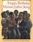 | Marzollo, J. (1993). Happy birthday, martin luther king. New York: Scholastic, Inc.  A picture biography of Martin Luther King ending with a brief allusion to the holiday which remembers his birthday in January.
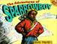 | Pinkney, J. B. (2000). The adventures of sparrowboy. New York: Aladdin Paperbacks. Retrieved from Children’s Literature. (2000). Reviews. http://www.childrenslit.com/childrenslit/mai_pinkney_brian.html  The adventures of Henry the paperboy when he is given the ability to fly by a sparrow and later discovers his need to return the gift to the sparrow.
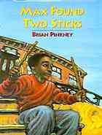 | Pinkney, J. B. (1994). Max found two sticks. New York: Simon & Schuster Books for Young People. Retrieved from Internet Archive. (n.d.) Open Library: Search Results. Retrieved from http://openlibrary.org/search?q=Max+found+two+sticks  A young boy who does not feel like talking responds by drumming with his two sticks on objects around him in the city.
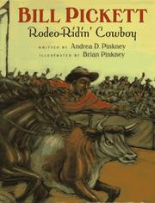 | Pinkney, A. D. (1996). Bill picket: Rodeo ridin’ cowboy. San Diego: Harcourt Brace & Co. Retrieved from Children’s Literature. (2000). Reviews. http://www.childrenslit.com/childrenslit/mai_pinkney_brian.html  A biography of a former slave who becomes a rodeo cowboy.
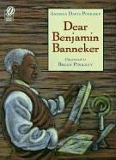 | Pinkney, A. D. (1998). Dear benjamin banneker. San Diego: Harcourt Brace. Retrieved from Children’s Literature. (2000). Reviews. http://www.childrenslit.com/childrenslit/mai_pinkney_brian.html  A biography about the 18th century African American scientist and mathematician who wrote an almanac, helped with the location of the nation’s capital, spoke about slavery.
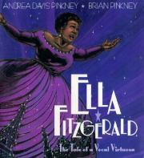 | Pinkney, A. D. (2002). Ella fitzgerald: The tale of a vocal virtuosa. New York: Jump in the Sun/Hyperion Books for Children. Retrieved from Children’s Literature. (2000). Reviews. http://www.childrenslit.com/childrenslit/mai_pinkney_brian.html  A biography about jazz great Ella Fitzgerald as narrated by a cat named Scat.
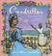 | San Souci, R. D. (1998). Cendrillon. New York: Aladdin Paperbacks.  Written from the godmother’s point of view, this is the tale of a Caribbean Cinderella and her “embroidered pink slippers.”
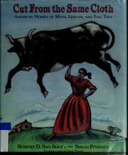 | San Souci, R. (1993). Cut from the same cloth: American women of myth, legend, and tall tale. New York: Philomel Books. Retrieved from Children’s Literature. (2000). Reviews. http://www.childrenslit.com/childrenslit/mai_pinkney_brian.html  Twenty tales of America’s legendary, e.g. Bess Call, Old Sally Cato, Ootoonah and others as drawn from folktales, legends, and ballads.
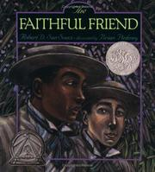 | San Souci, R. D. (1995). The faithful friend. New York: Simon and Schuster Books for Young Readers.  The classic story from the island of Martinique of two devoted friends, Clement and Hippolyte, and their sacrifice for each other captures the reader’s interest for true friendship, romance, and adventure.
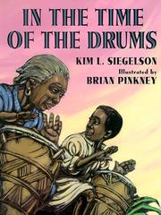 | Siegelson, K. (1999). In the time of the drums. New York: Jump in the Sun/Hyperion Books for Children. Retrieved from Children’s Literature. (2000). Reviews. http://www.childrenslit.com/childrenslit/mai_pinkney_brian.html  A story about an American-born slave boy who learns the stories and songs and drumming of his cultural heritage, the Ibo people, from his grandmother and his witness of the Teakettle Creek slave insurrection.
Floyd Cooper: A Selected Set
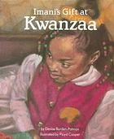 | Burden-Patmon, D. (1992). Imani’s gift at kwanzaa. Cleveland: Modern Curriculum Press. Retrieved from Children’s Literature. (1999). Reviews. http://www.childrenslit.com/childrenslit/mai_cooper_floyd.html  A young African American girl learns the meaning of Kwanzaa; presents the concept of Kwanzaa through a narrative.
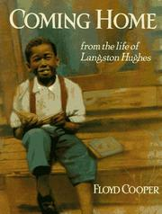 | Cooper, F. (1994). Coming home: From the life of langston hughes. New York: Philomel Books. Retrieved from Children’s Literature. (1999). Reviews. http://www.childrenslit.com/childrenslit/mai_cooper_floyd.html  A biography of the childhood of Langston Hughes and his search for closer family relationships and its influence on his poem. Written and illustrated by Floyd Cooper.
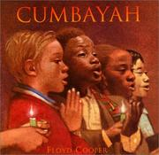 | Cooper, F. (1998). Cumbayah. New York: Morrow Junior Books. Retrieved from Children’s Literature. (1999). Reviews. http://www.childrenslit.com/childrenslit/mai_cooper_floyd.html  A retelling of the African American folk song. The review states each verse is accompanied by an illustration.
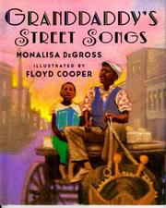 | DeGross, M. (1999). Granddaddy’s street songs. New York: Jump at the Sun/Hyperion Books for Children. Retrieved from Children’s Literature. (1999). Reviews. http://www.childrenslit.com/childrenslit/mai_cooper_floyd.html  A young boy learns about his grandfather’s youth as a street vendor in Baltimore
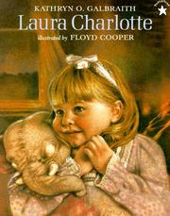 | Galbraith, K. O. (1997). Laura charlotte. New York: PaperStar.  A story of a stuffed toy beloved by two little girls of two generations - a mother when she was young and who then shares it with her daughter.
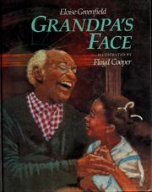 | Greenfield, E. (1988). Grandpa’s face. New York: Philomel Books. Retrieved from Children’s Literature. (1999). Reviews. http://www.childrenslit.com/childrenslit/mai_cooper_floyd.html  A young girl fears the mean face her grandfather makes for a play in which he is acting, hoping it will not be turned toward her.
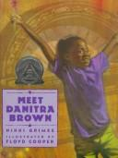 | Grimes, N. (1994). Meet danitra brown. New York: Lothrop, Lee & Shepherd. Retrieved from Children’s Literature. (1999). Reviews. http://www.childrenslit.com/childrenslit/mai_cooper_floyd.html  A series of poems showing the friendship and dreams of two young girls.
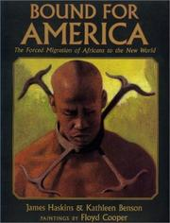 | Haskins, J. & Benson, K. (1999). Bound for america: The forced migration of africans to the new world. New York: Lothrop, Lee & Shepherd. Retrieved from Children’s Literature. (1999). Reviews. http://www.childrenslit.com/childrenslit/mai_cooper_floyd.html  Presents the history of the enslavement of Africans to the American colonies. The review recommends this book and “African Beginnings,” the first in the series, for children ages 8 and up.
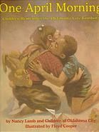 | Lamb, N. and Children of Oklahoma City. (1996). One april morning: Children remember the oklahoma city bombing. New York: Lothrop, Lee & Shepherd. Retrieved from Children’s Literature. (1999). Reviews. http://www.childrenslit.com/childrenslit/mai_cooper_floyd.html  Children’s account of their experiences and emotions about the bombing of the Federal Building. The review states that the initial interviews were completed a few months after the event.
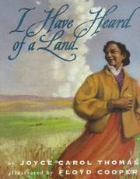 | Thomas, J. C. (1988). I have heard of a land. New York: HarperCollins Publisher. Retrieved from Children’s Literature. (1999). Reviews. http://www.childrenslit.com/childrenslit/mai_cooper_floyd.html  The story of an African American woman staking her claim in the first year’s settlement of the Oklahoma Territory.
All book covers obtained through Internet Archive’s Open Library at http://openlibrary.org/about

Reference
Answers Corporation. (2012). (Jerry) Brian pinkney. Retrieved October 29, 2012 from http://www.answers.com/topic/jerry-brian-pinkney
Brian Pinkney. (2012). Bibliography. Retrieved October 29, 2012 from http://www.brianpinkney.net/main.html
Brian Pinkney. (2012). FAQ: What is scratchboard? Retrieved October 29, 2012 from http://www.brianpinkney.net/main.html
The Brown Bookshelf. (2009). Floyd cooper. Retrieved October 29, 2012 from http://thebrownbookshelf.com/2009/02/10/floyd-cooper/
Children’s Literature Network. (2002-2008). Birthday bios: Floyd cooper. Retrieved October 31, 2012 from http://www.childrensliteraturenetwork.org/birthbios/brthpage/01jan/1-8cooper.html
Children’s Literature Network. (2002-2008). Birthday bios: Gloria pinkney. Retrieved October 29, 2012 from http://www.childrensliteraturenetwork.org/birthbios/brthpage/09sep/9-5pinkneyg.html
Courtot, M. (1999). Children’s literature: Meet authors and illustrators: Floyd cooper. Retrieved October 31, 2012 from http://www.childrensliteraturenetwork.org/birthbios/brthpage/01jan/1-8cooper.html
HarperCollins Publisher. (2012). Author: Floyd cooper. Retrieved October 31, 2012 from http://www.harpercollins.com/authors/11961/Floyd_Cooper/index.aspx
Houghton Mifflin Company. (n.d.). Meet brian pinkney. Retrieved October 29, 2012 from http://www.eduplace.com/kids/tnc/mtai/bpinkney.html
Houghton Mifflin Company. (n.d.). Meet the author/illustrator: Floyd cooper. Retrieved October 31, 2012 from http://www.eduplace.com/kids/hmr/mtai/fcooper.html
Internet Archive. (2010, July 27). About us. Retrieved October 31, 2012 from http://openlibrary.org/about
Jerry Pinkney Studio. (2012). Children’s books. Retrieved October 29, 2012 from http://www.jerrypinkneystudio.com/frameset.html
Ord, P. A. (2000). Children’s literature: Meet authors and illustrators: Brian pinkney. Retrieved October 29, 2012 from http://www.childrenslit.com/childrenslit/mai_pinkney_brian.html
Tunnell, M. O., Jacobs, J. S., Young, T. A. & Bryan, G. (2012). Children's Literature, Briefly. (5th ed.). Boston: Pearson Education, Inc.

Bibliography
Answer Corporation. (2012). Eloise Greenfield. Retrieved October 31, 2012 from http://www.answers.com/topic/eloise-greenfield
Art Materials/The Art Store. (2001-2010). Luma bleed-proof white. Retrieved October 29, 2012 from http://www.shoptheartstore.com/product_detail_single.cfm?productID=B0CC495A-37F1-4A27-84C069650F327C53&parentCat=D0C2D5F2-B94D-4AA3-A5F9B93D643C1D75&topCat=ca10dc26-fef2-42b5-bc5a5d7afbdd7051
Crane, C. (2012, October 3). Chapter 7: Picture books. [PowerPoint presentation] Retrieved from LIBR263 Course Content, San Jose State University School of Library and Information Science.
Dick Blick Holdings, Inc. (1999-2012). Prismacolor kneaded color erasers. Retrieved October 29, 2012 from http://www.dickblick.com/products/prismacolor-kneaded-rubber-erasers/
Hvinden, A. (2012, October 3). Chapter 7: Picture books. [PowerPoint presentation] Retrieved from LIBR263 Course Content, San Jose State University School of Library and Information Science.
Library of Congress. (n.d.). Webcast: Floyd cooper: Bookfest 2004. Retrieved October 31, 2004 from http://www.loc.gov/today/cyberlc/feature_wdesc.php?rec=3589

Illustrators | 9-10
Content:  Directions: Use 6-8 double spaced pages.  - Choose two children’s illustrators (living or dead). Provide a biographical sketch (150-300 words) of each. Many children’s book authors illustrate their own books.  - Answer this question: How do the illustrator’s background, experiences, and cultural perspective influence his/her illustration technique?  - Write a short analysis of the technique that each illustrator focuses on in his/her work.  - Provide a brief, annotated bibliography of the illustrator’s works. Include photographs if you like.  - Provide a list of sources that you used to learn about the illustrators. | Assignment meets or exceeds all requirements.  10 points
References and citations:  - Assignment shows judicious and applicable use of quotes and paraphrases.  - Quotes and paraphrases add to the discussion of the subject, but do not overwhelm it.  - Quotes are in the correct format.  - Required in-text citations are present and in correct format.  - Sources in the Sources Cited list are reflected in the assignment text.  - Bibliographic citations are correct and consistent.  - Textbook(s) is/are cited | Assignment meets all criteria for use of quotes, paraphrases and citations. 3 points
Writing style and presentation:  - Report is free of typos, punctuation errors, spelling errors, and grammatical errors.  - Arrangement is clear and logical  - Writing incorporates varied, interesting, appropriate vocabulary and sentence structure.  - Written in third-person, objective, gender-free style.  - Approximately 6-8 pages, double-spaced. (Including tables). | Assignment meets all criteria for writing style. 2 points

