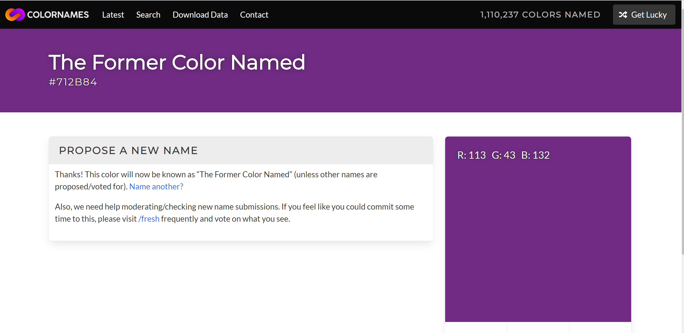
By Femy Wesolowski
April 14, 2020

